5.14: a) In level flight, the thrust and drag are horizontal, and the lift and weight are vertical. At constant speed, the net force is zero, and so 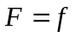and 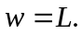 b) When the plane attains the new constant speed, it is again in equilibrium and so the new values of the thrust and drag, 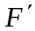 and 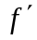, are related by 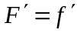; if 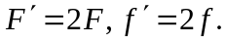 c) In order to increase the magnitude of the drag force by a factor of 2, the speed must increase by a factor of .

